Project: Todo Business Requirements
Course: CSD 380 DevOps
Description: Todo is a business application focused on the monitoring of task items. Users of this system are able to create, update, and delete items from their “Todo List.” Views have been created to support most major devices and web browsers.
Date: 2026/06/25
To complete the test case plan, fill out the information for Project, Course, Description and Date in the header below.
.
TABLE OF CONTENTS
Create and View Todo Task Item 2
Edit Todo Task Item 3
Delete Todo Task, Error Page, and Responsive Views 3
Invalid URL and Custom 404 Error Page 4
Responsive Mobile and Tablet Views 5

For each test, the developer should: provide a test description, a test objective, the developer name and date tested. For each step, fill out the actions to be taken and describe the expected results, and indicate yes or no for each step depending upon the result. The peer tester should provide their name, date tested, indicate yes or no for each step depending upon the result, and a screenshot (thumbnail) of the result.

Test 1 | Create and View Todo Task Item
 | Test Objective: Verifies that users can visit the website, create todo task items, view the Todo List, and are prevented from submitting a blank task form. | Developer:  Date tested: 2026/06/25 | Peer tester: Alexander Baldree  Date tested: 2026/06/25
Step | Action | Expected results: | Developer pass/fail | Tester pass/fail  + Screenshot
1 | Open the Todo application at https://buwebdev.github.io/todo/. | The landing page loads successfully and shows the Task Form, todo input field, Add Task button, and Todo List section. | Yes | Yes  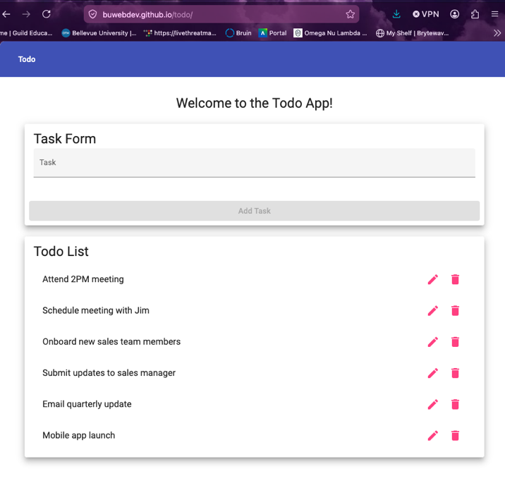
2 | Enter the task item "Attend 2PM meeting" into the task form and select Add Task. | The todo item is added to the Todo List and displays as "Attend 2PM meeting." | Yes | Yes  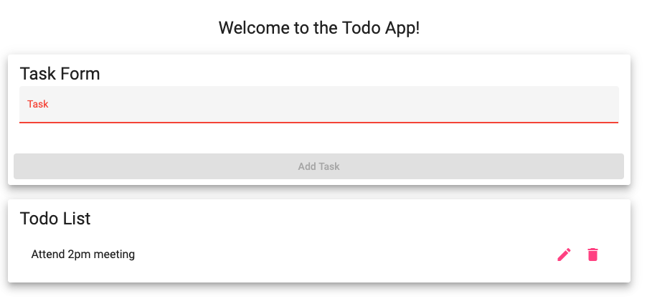
3 | Enter a second task item, "Schedule meeting with Jim," and select Add Task. | The new item is added without removing the first item, and the Todo List displays both tasks. | Yes | Yes  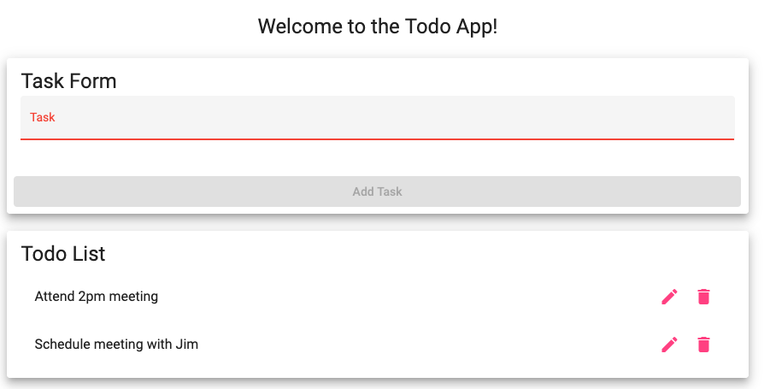
4 | Review the Todo List after adding items. | The list is readable, organized, and displays the created task items for the user. | Yes | Yes  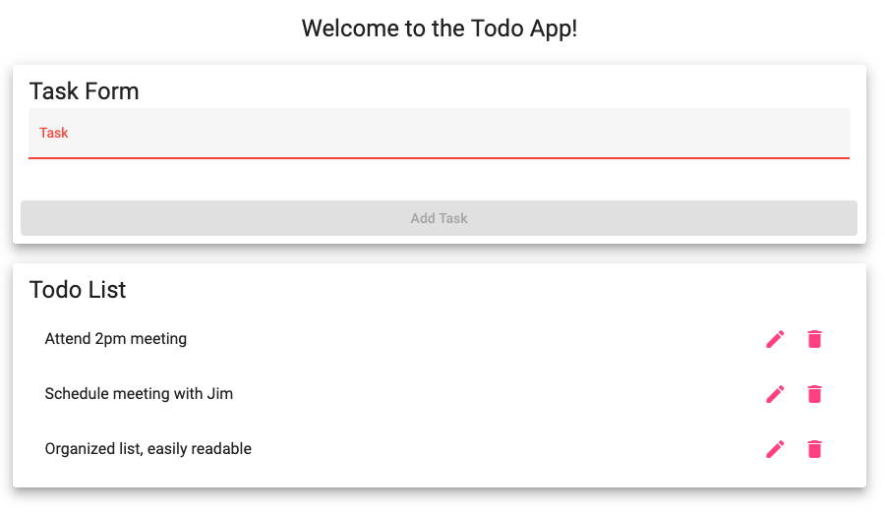
5 | Leave the task form blank and select Add Task. | The application prevents submission without a todo item and does not add a blank task to the list. | Yes | No, I can push space Four times and it allow me to add task  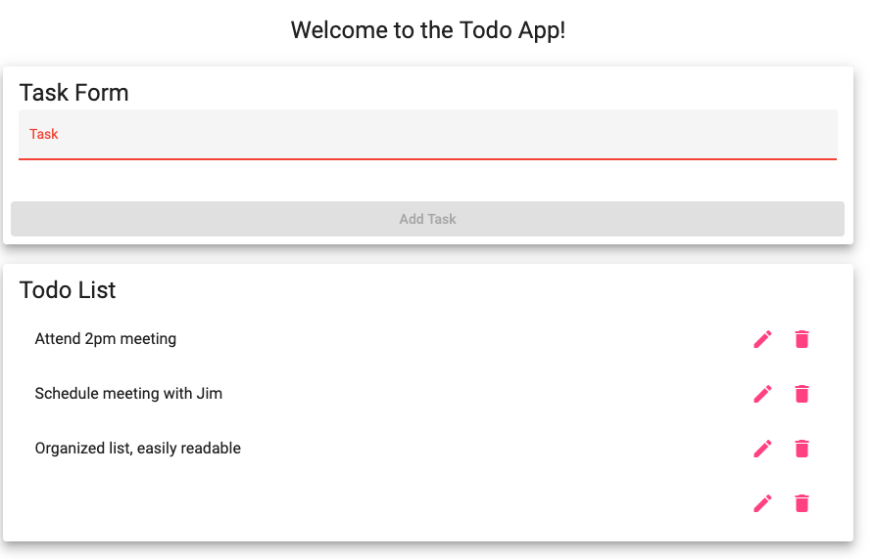
Comments | Great work, Everything added up besides the blank tasks allowed to insert into list. I don’t believe this is something that you can fix unless the instructor know of a way, because spaces are considered characters. – Alexander Baldree

Test 2 | Edit Todo Task Item
 | Test Objective: Verifies that users can update an existing todo task item and that the edit form prevents blank submissions. | Developer:  Date tested: 2026/06/25 | Peer tester: Alexander Baldree  Date tested: 2026/06/25
Step | Action | Expected results: | Developer pass/fail | Tester pass/fail
1 | Create or locate an existing todo item named "Attend 2PM meeting." | The selected todo item is visible in the Todo List and can be opened for editing. | Yes | Yes  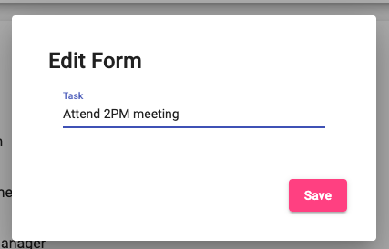
2 | Open the edit option or edit view for the selected todo item. | The Edit Form opens and displays the current task text in the input field. | Yes | Yes  
3 | Change the task text to "Attend 3PM meeting" and select Save. | The application saves the change and returns the user to the updated Todo List. | Yes | Yes  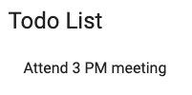
4 | Verify the updated task item in the Todo List. | The list displays "Attend 3PM meeting" and no longer displays the old "Attend 2PM meeting" text for that item. | Yes | Yes  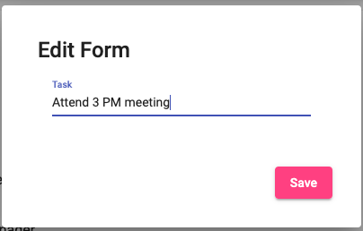
5 | Open the edit form again, clear the input field, and select Save. | The application prevents saving an empty todo item and keeps the user from creating a blank task value. | Yes | No  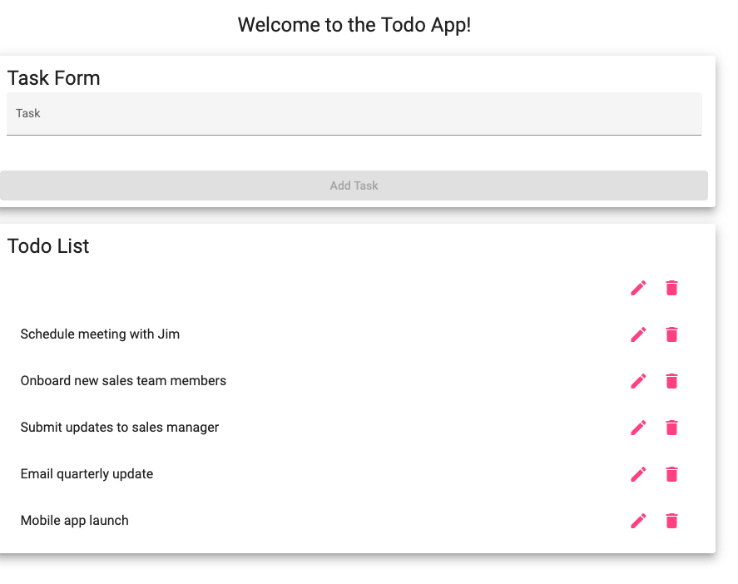
Comments | Great work! Everything worked well except the same bug. It still allows me to edit a task; blank; and it submits it blank. –Alexander Baldree

Test 3 | Delete Todo Task, Error Page, and Responsive Views
 | Test Objective: Verifies that users can delete task items, receive a custom 404 page for invalid URLs, and use the application on mobile and tablet views. | Developer:  Date tested: 2026/06/25 | Peer tester: Alexander Baldree  Date tested: 2026/06/25
Step | Action | Expected results: | Developer pass/fail | Tester pass/fail
1 | Create or locate a todo item named "Onboard new sales team members." | The item is visible in the Todo List and is available for deletion testing. | Yes | Yes  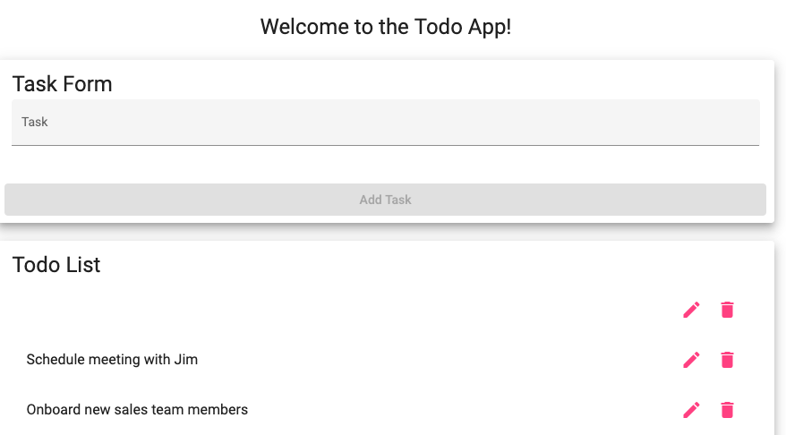
2 | Use the delete control or delete action for the selected todo item. | The selected todo item is removed from the Todo List. | Yes | Yes  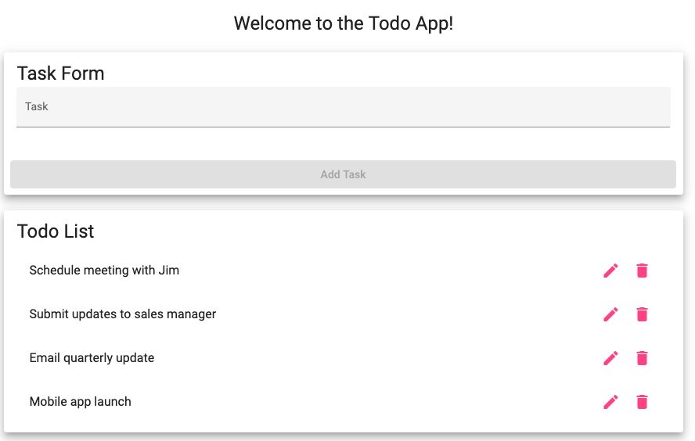
3 | Refresh or revisit the Todo List view. | The deleted item does not reappear in the current Todo List view. | Yes | No  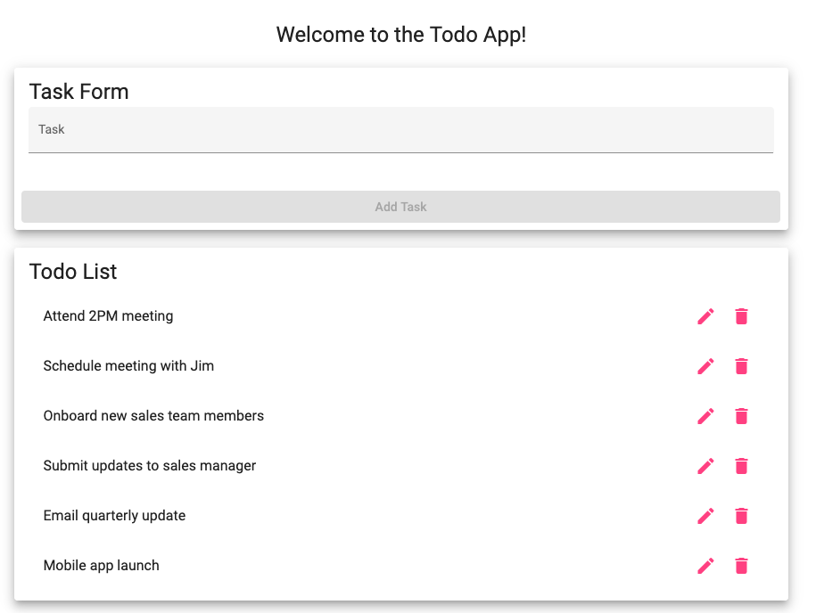
4 | Navigate to an invalid page such as https://buwebdev.github.io/todo/not-a-real-page. | The application displays a custom 404 error page instead of a generic or broken browser error. | Yes | Yes  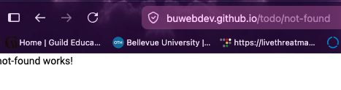
5 | View the Todo application using mobile-width and tablet-width browser sizes. | The application remains usable and readable on mobile and tablet views, including the task form, Add Task button, edit view, and Todo List. | Yes | Yes  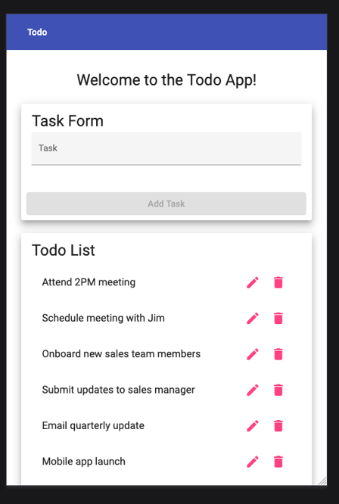
Comments | Great Work! When I refreshed the page through firefox, it loaded the original Todo list when website loaded first. The error not found was a great example of showing the real page doesn’t exist and could only be accessed through the real site link. – Alexander Baldree

Test 4 | Invalid URL and Custom 404 Error Page
 | Test Objective: Verifies that invalid application URLs show a custom 404 error page instead of a generic browser or server error. | Developer:  Date tested: 2026/06/25 | Peer tester: Alexander Baldree  Date tested: 2026/06/25
Step | Action | Expected results: | Developer pass/fail | Tester pass/fail
1 | Open the Todo application homepage at https://buwebdev.github.io/todo/. | The valid Todo application page loads successfully. | Yes | Yes  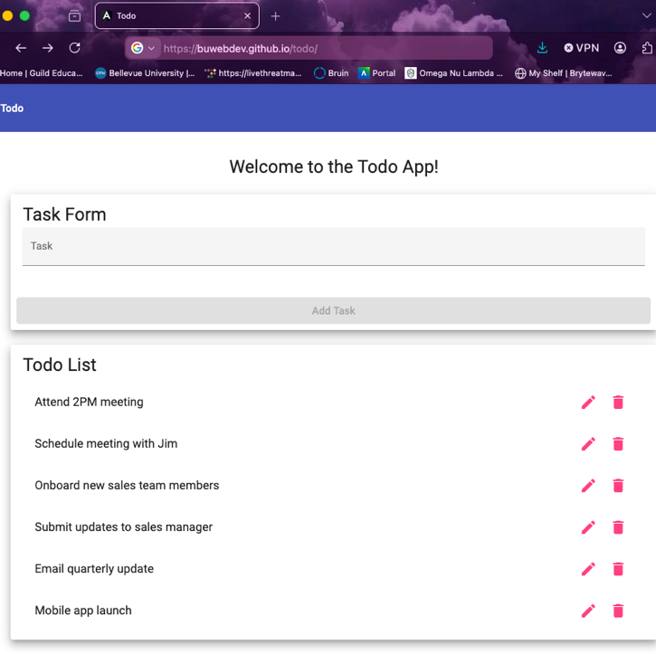
2 | Change the address to an invalid route, such as https://buwebdev.github.io/todo/invalid-page. | The user is taken to an error page for the invalid URL. | Yes | Yes  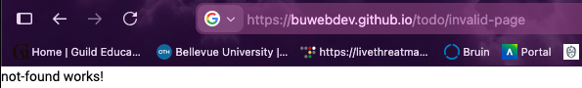
3 | Review the content of the error page. | The page clearly indicates that the requested page cannot be found. | Yes | Yes  
4 | Confirm the error page is styled for the Todo website rather than displaying only a generic browser error. | The invalid route displays a custom 404 error page or custom application error view. | Yes | Yes  
5 | Use the browser Back button or navigate back to https://buwebdev.github.io/todo/. | The user can return to the Todo application homepage successfully. | Yes | Yes  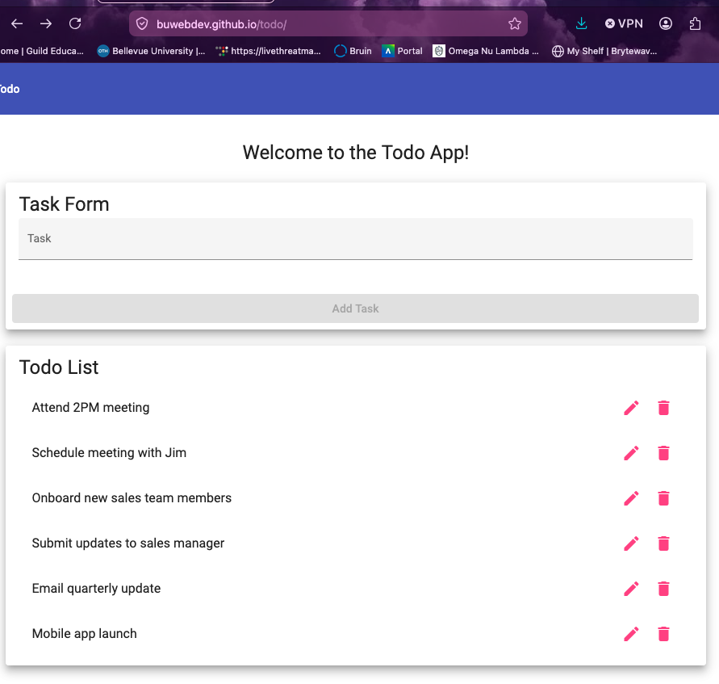
Comments | Great Work! This feels like the same tests as before, same concept. In general, great job with executing the test applied. – Alexander Baldree

Test 5 | Responsive Mobile and Tablet Views
 | Test Objective: Verifies that the Todo application provides usable views for mobile and tablet screen sizes. | Developer:  Date tested: 2026/06/25 | Peer tester: Alexander Baldree  Date tested: 2026/06/25
Step | Action | Expected results: | Developer pass/fail | Tester pass/fail
1 | Open https://buwebdev.github.io/todo/ in a desktop browser. | The Todo application loads successfully in the browser. | Yes | Yes  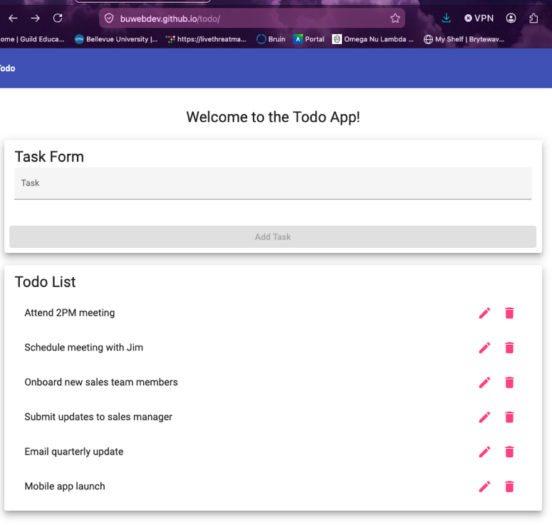
2 | Use browser developer tools or a responsive testing mode to view the page at a mobile width. | The Task Form, Add Task button, and Todo List remain visible and usable on a mobile-sized screen. | Yes | Yes  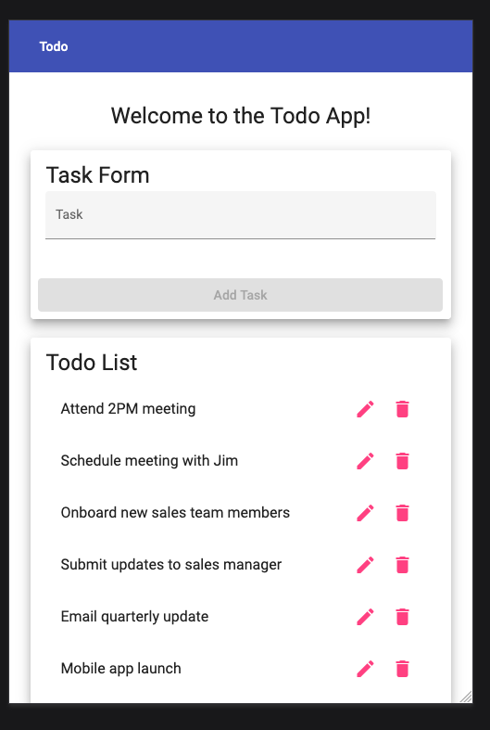
3 | Create a todo item while using the mobile-sized view. | The new todo item is added to the Todo List without layout issues. | Yes | Yes  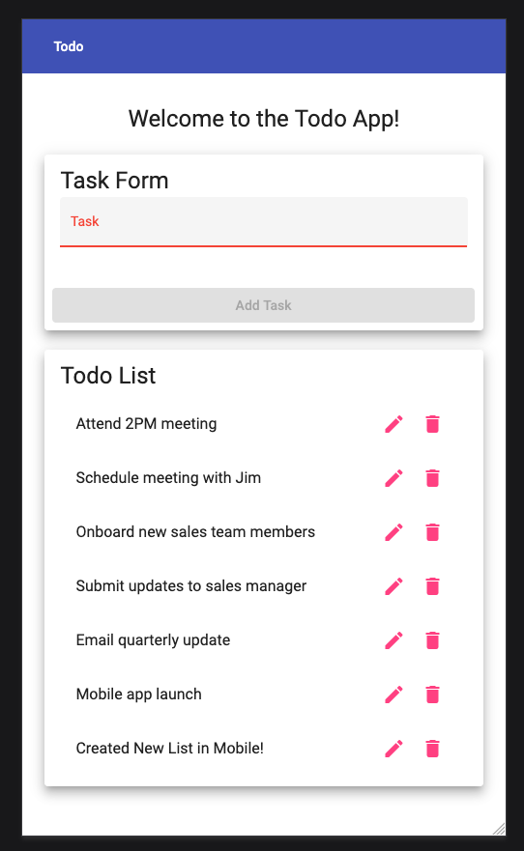
4 | Switch the responsive testing mode to a tablet-sized screen. | The Task Form, Add Task button, and Todo List remain readable and properly arranged on a tablet-sized screen. | Yes | Yes  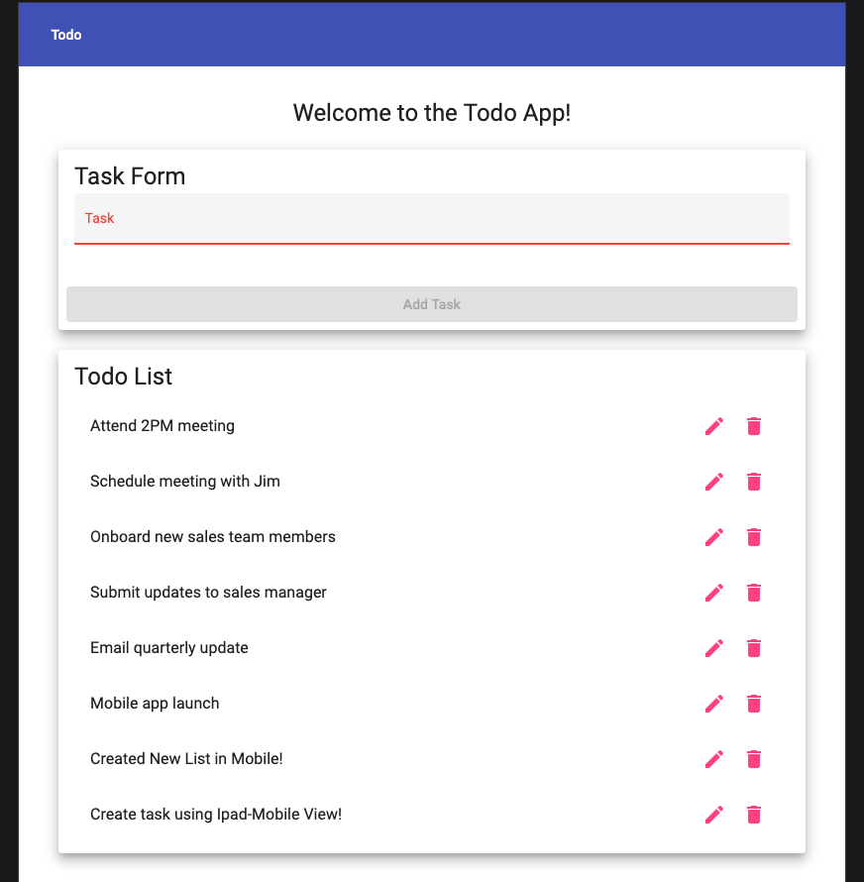
5 | Edit or delete a todo item while using the tablet-sized view. | The selected todo action works correctly and the layout remains usable. | Yes | Yes  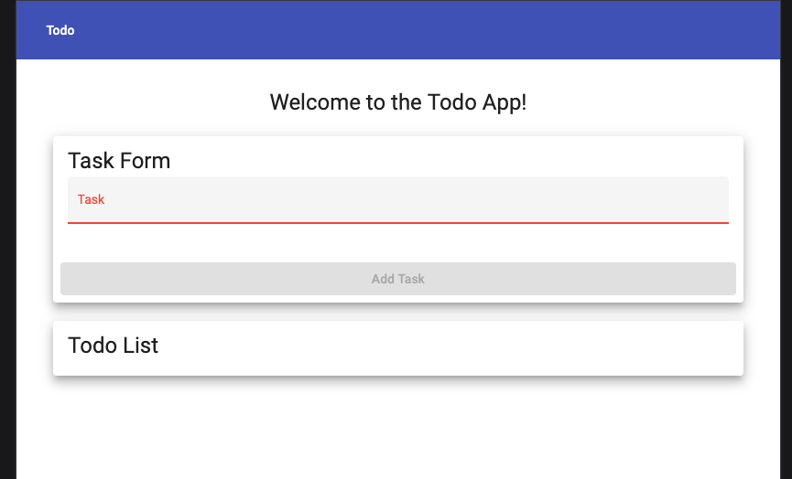
Comments | Great Work! I liked that you integrated Mobile, and Desktop Views and usability. This really allows us as developers to really test those environments without having to run on an individual device separated from production. – Alexander Baldree

